|  |  |
| --- | --- |
| **Student Name** | Sachin Hegde |
| **Project Name** | LockedMe Project |
| **Phase and Batch** | Java FSD Phase-1 Feb Mar-2022 |
| **Technology Used** | Java Programming |
| **Java Concepts used** | Object Oriented concepts,Collections,File Concepts, Exception Handling |

**Project Folder Structure :**

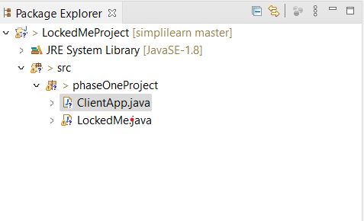

**Source Code :**

**LockedMe.java :**

package phaseOneProject;

import java.io.File;

import java.io.FileWriter;

import java.util.ArrayList;

import java.util.Scanner;

public class LockedMe {

static final String projectFiles="E:\\projectfiles";

/**

* Lists all the menu

*/

public static void menuList() {

System.out.println("----------------------------");

System.out.println("Welcome to LockedMe.com");

System.out.println("Devoloped By : Sachin Hegde");

System.out.println("----------------------------");

System.out.println("\t1.Display Files");

System.out.println("\t2.Add a new File");

System.out.println("\t3.Delete a File");

System.out.println("\t4.Search File");

System.out.println("\t5.Exit");

System.out.println("----------------------------");

}

/**

* Display all the files in the folder

*/

public static void displayFiles() {

File file = new File(projectFiles);

// returns an array of all files

File[] fileList = file.listFiles();

for(File fname : fileList) {

System.out.println(fname.getName());

}

}

/**

* takes files name and number of lines from the user and create the file

*/

public static void addFile() {

try {

Scanner sc=new Scanner(System.in);

String fileName;

System.out.println("Enter File Name to Add");

fileName=sc.nextLine();

int lineCnt;

System.out.println("Enter Lines Count");

lineCnt=Integer.parseInt(sc.nextLine());

FileWriter fw=new FileWriter(projectFiles+"\\"+fileName);

for(int i=1;i<=lineCnt;i++) {

System.out.println("Enter Line "+i+" content :");

fw.write(sc.nextLine()+"\n");

}

System.out.println("File Crated Successfuly");

fw.close();

}

catch(Exception e) {

System.out.println("There is an error");

}

}

/**

* takes files name and from the user and delete the file if present

*/

public static void deleteFile() {

try {

Scanner sc=new Scanner(System.in);

String fileName;

ArrayList<String> allFiles=new ArrayList<String>();

File folder = new File(projectFiles);

// returns an array of all files

File[] fileList = folder.listFiles();

if(fileList.length>0) {

System.out.println("Files List");

for(File fname : fileList) {

System.out.println(fname.getName());

allFiles.add(fname.getName());

}

}

System.out.println("Enter File Name to be deleted");

fileName=sc.nextLine();

File f=new File(projectFiles+"\\"+fileName);

if(allFiles.contains(fileName)) {

f.delete();

System.out.println("File Deleted Successfuly");

}

else {

System.out.println("File Not exist");

}

}

catch(Exception e) {

System.out.println("There is an error");

}

}

/**

* takes files name and from the user and searches the file

*/

public static void seachFile() {

try {

Scanner sc=new Scanner(System.in);

String fileName;

ArrayList<String> allFiles=new ArrayList<String>();

File folder = new File(projectFiles);

File[] fileList = folder.listFiles();

if(fileList.length>0) {

for(File fname : fileList) {

allFiles.add(fname.getName());

}

}

System.out.println("Enter File Name");

fileName=sc.nextLine();

File f=new File(projectFiles+"\\"+fileName);

if(allFiles.contains(fileName)) {

System.out.println("File Present");

}

else {

System.out.println("File Not exist");

}

}

catch(Exception e) {

System.out.println("There is an error");

}

}

}

**ClientApp.java**

**package** phaseOneProject;

**import** java.util.Scanner;

**public** **class** ClientApp {

**public** **static** **void** main(String[] args) {

Scanner obj=**new** Scanner(System.***in***);

**int** ch;

**do** {

LockedMe.*menuList*();

System.***out***.println("Enter Your Choice : ");

ch=Integer.*parseInt*(obj.nextLine());

**switch**(ch) {

**case** 1:LockedMe.*displayFiles*();

**break**;

**case** 2:LockedMe.*addFile*();

**break**;

**case** 3:LockedMe.*deleteFile*();

**break**;

**case** 4:LockedMe.*seachFile*();

**break**;

**case** 5:System.*exit*(0);

**break**;

**default**:System.***out***.println("Invalid Option");

**break**;

}

}

**while**(ch>0);

obj.nextLine();

obj.close();

}

}

**Screen Shots**

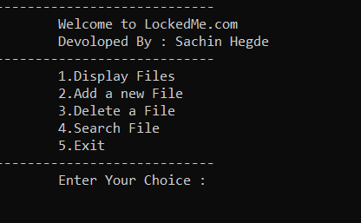

Menu list

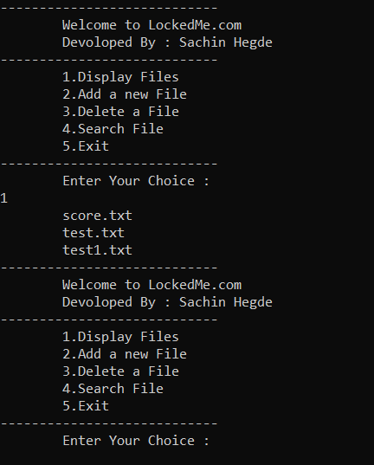

Display all files

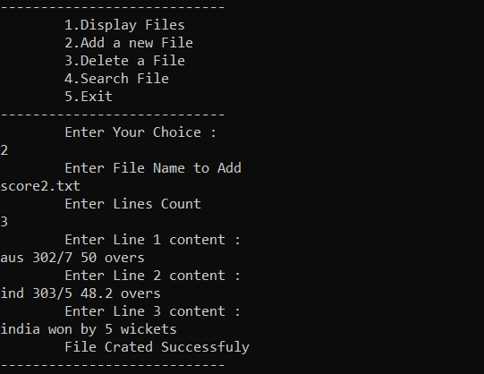

Add a file

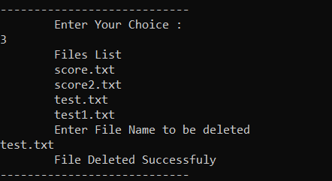

Delete a file

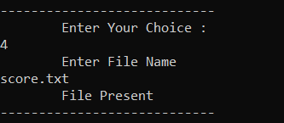

Search a file

**GitHub URL :** https://github.com/SachinHegde1997/PhaseOne-Project.git